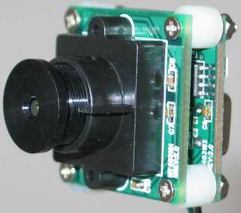
Digital camera
Figure 1 Board Level Camera module
• Pixels: 1280 × 1024
• Pixel Size: 5.2μ × 5.2μ
• Image Size: 1.28 Mbyte/picture
• Interface: USB 2.0
• Power supply: 5 V (USB bus power)
200 mA
• Camera size: 28 × 28 × 32 mm
• Price: $ 149.00
• Field of view: 107° Horizontal
78° Vertical
• Altitude: no more than 350 m
• Coverage: 945.90 m × 566.85 m
• Resolution: 0.96 m
• Mass: nearly 150 gram
• Spectral Response: 400 ~ 1000 nm
• Lens mounting base: M12 × 0.5
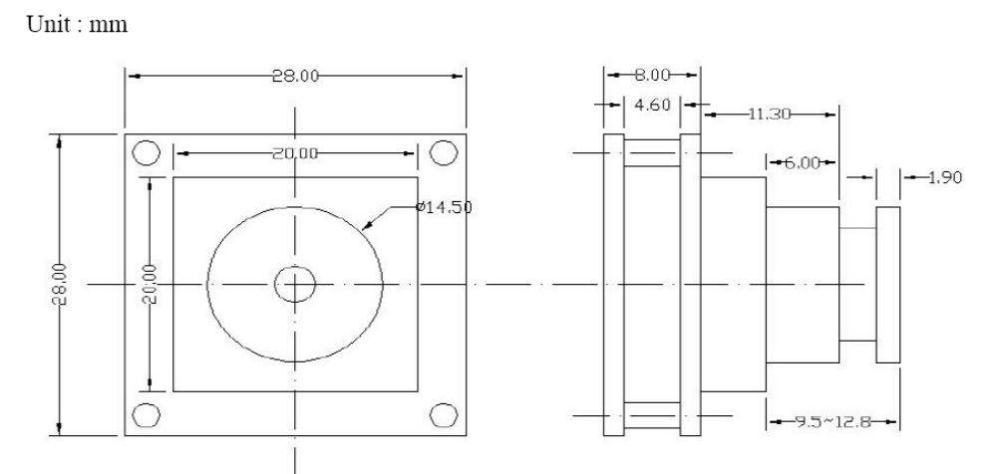
Figure 2 Mechanical Drawing

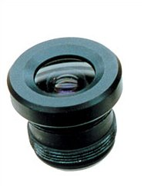
Extra lens (1.9 mm "fish-eye" lens)
Figure 3 1.9 mm "fish-eye" lens
• Format: 1/4"
• Focal Length (mm): 1.9 mm
• Back Focal Length (mm): 4.1 mm
• Aperture (F): 2.0
• IR filter coating: No
• Angle of View (DIA) 1/4": (H) 107° / (V) 78°
• Lens construction: 5-5
• Dimension (mm): 15.1 × 18.8
• Weight: 4.5 gram
• Price: $ 35.95

Servo Motor
Motor Type: Micro-servo
Torque: 0.4 kg·cm (4.8 V DC); 0.5 kg·cm (6.0 V DC)
Direction: Clockwise / pulse traveling 1500 to 1900 µs
Power: 4.8 V DC – 6.0 V DC / 100 mA
Size: 19.6 x 17.6 x 8 mm
Cost: $ 5

Total cost $ 189.95
Shipping and handling: ?

